MIS 6326.501 – Data Management - Assignment 6B
Swetha Krishnakumar (sxk151530)

Assignment 6B Analytical Processing

Total points: 25

This assignment should be completed individually. For each problem, submit your SQL statement and a screen shot of the SQL results in a single Word document or pdf file. Submit the file via eLearning.

I recommend creating a new user and workspace, log in as that user and load the database script DWDBINIT.sql (provided in this week's assignment folder).
Before you attempt to write any SQL queries, familiarize yourself with the database structure and data. I have provided a relational diagram and sample data for this database.
Write queries to address each of the problems below. Submit both the SQL statements and the screen prints of the outputs from Oracle.
SaleCo Snowflake schema

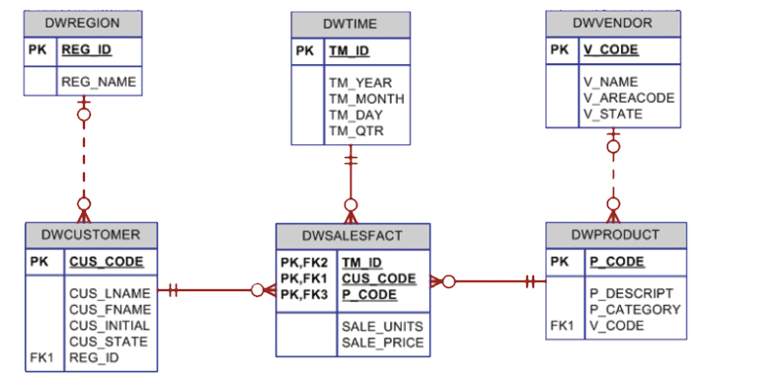

(Hint: You will be using the ROLLUP and CUBE commands.)

- List the total sales by customer and by product, with subtotals by customer and a grand total for all product sales.

Solution:
Select CUS_CODE, P_CODE, SUM(SALE_UNITS * SALE_PRICE) AS TOTAL_SALES FROM DWDAYSALESFACT NATURAL JOIN DWCUSTOMER NATURAL JOIN DWPRODUCT GROUP BY ROLLUP (CUS_CODE,P_CODE) ORDER BY CUS_CODE,P_CODE

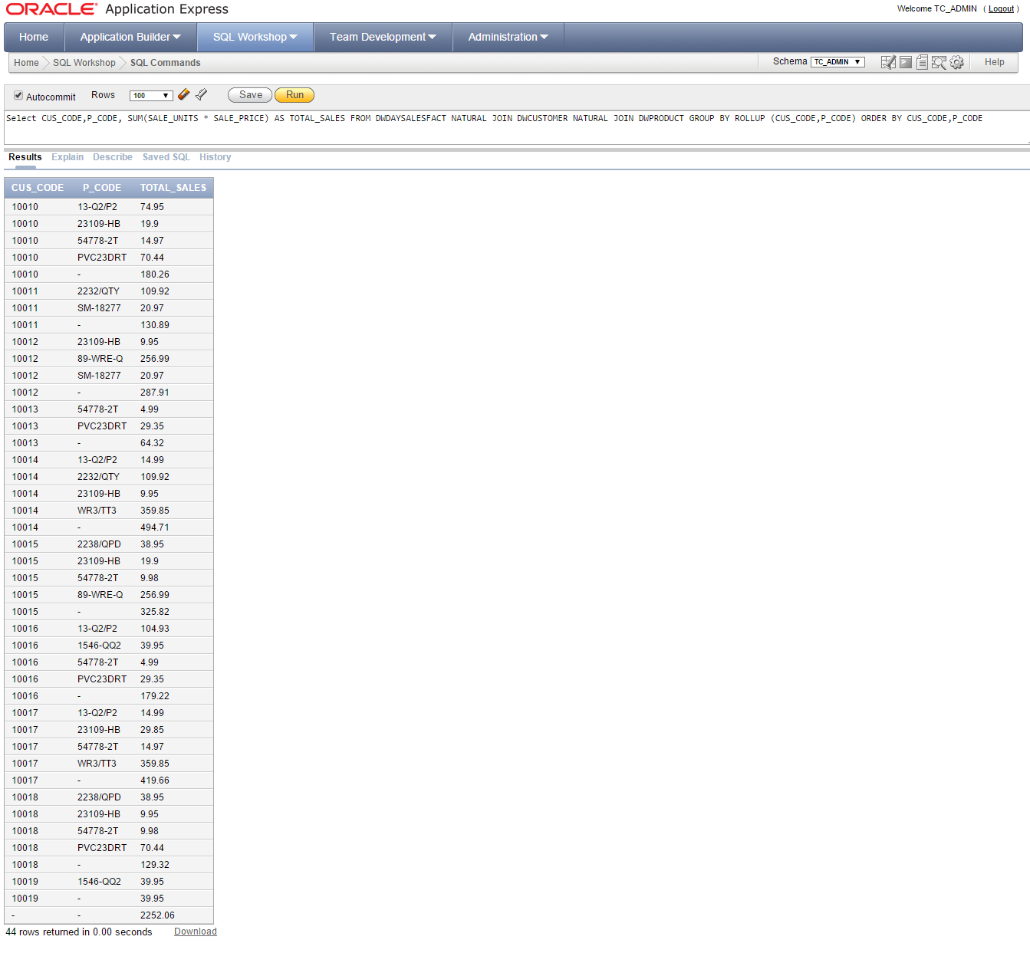

Solution 2:
Select CUS_CODE,CUS_LNAME,CUS_FNAME,P_CODE, SUM(SALE_UNITS * SALE_PRICE) AS TOTAL_SALES FROM DWDAYSALESFACT NATURAL JOIN DWCUSTOMER NATURAL JOIN DWPRODUCT GROUP BY ROLLUP (CUS_CODE,CUS_LNAME,CUS_FNAME,P_CODE) ORDER BY CUS_CODE,P_CODE

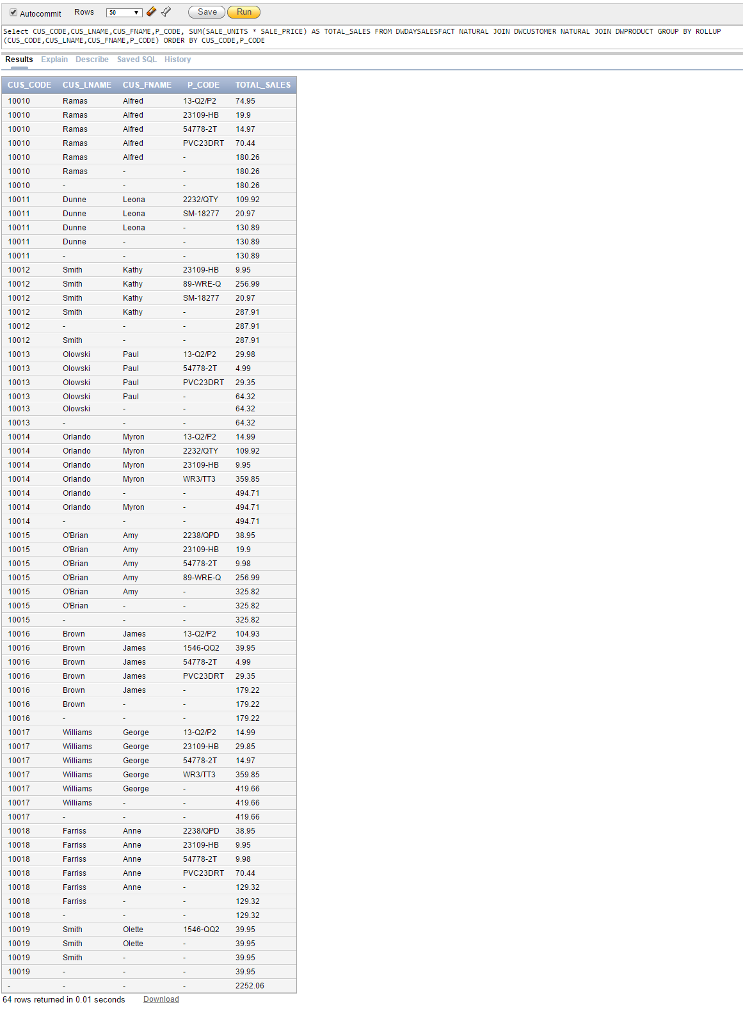

2. List the total sales by customer, month and product, with subtotals by customer and by month and a grand total for all product sales.

Solution:
Select CUS_CODE,TM_MONTH,P_CODE, SUM(SALE_UNITS * SALE_PRICE) AS TOTAL_SALES FROM DWDAYSALESFACT NATURAL JOIN DWCUSTOMER NATURAL JOIN DWPRODUCT NATURAL JOIN DWTIME GROUP BY ROLLUP(CUS_CODE,TM_MONTH,P_CODE) ORDER BY CUS_CODE,TM_MONTH

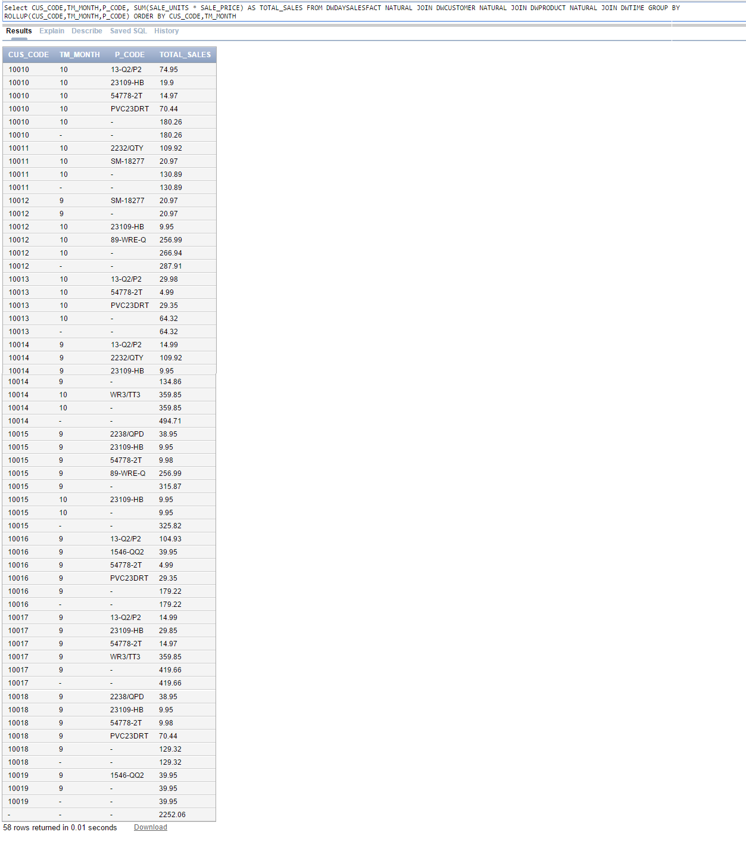
Solution 2:
Select CUS_CODE,CUS_LNAME,CUS_FNAME,TM_MONTH,P_CODE, SUM(SALE_UNITS * SALE_PRICE) AS TOTAL_SALES FROM DWDAYSALESFACT NATURAL JOIN DWCUSTOMER NATURAL JOIN DWPRODUCT NATURAL JOIN DWTIME GROUP BY ROLLUP(CUS_CODE,CUS_LNAME,CUS_FNAME,TM_MONTH,P_CODE) ORDER BY CUS_CODE,TM_MONTH
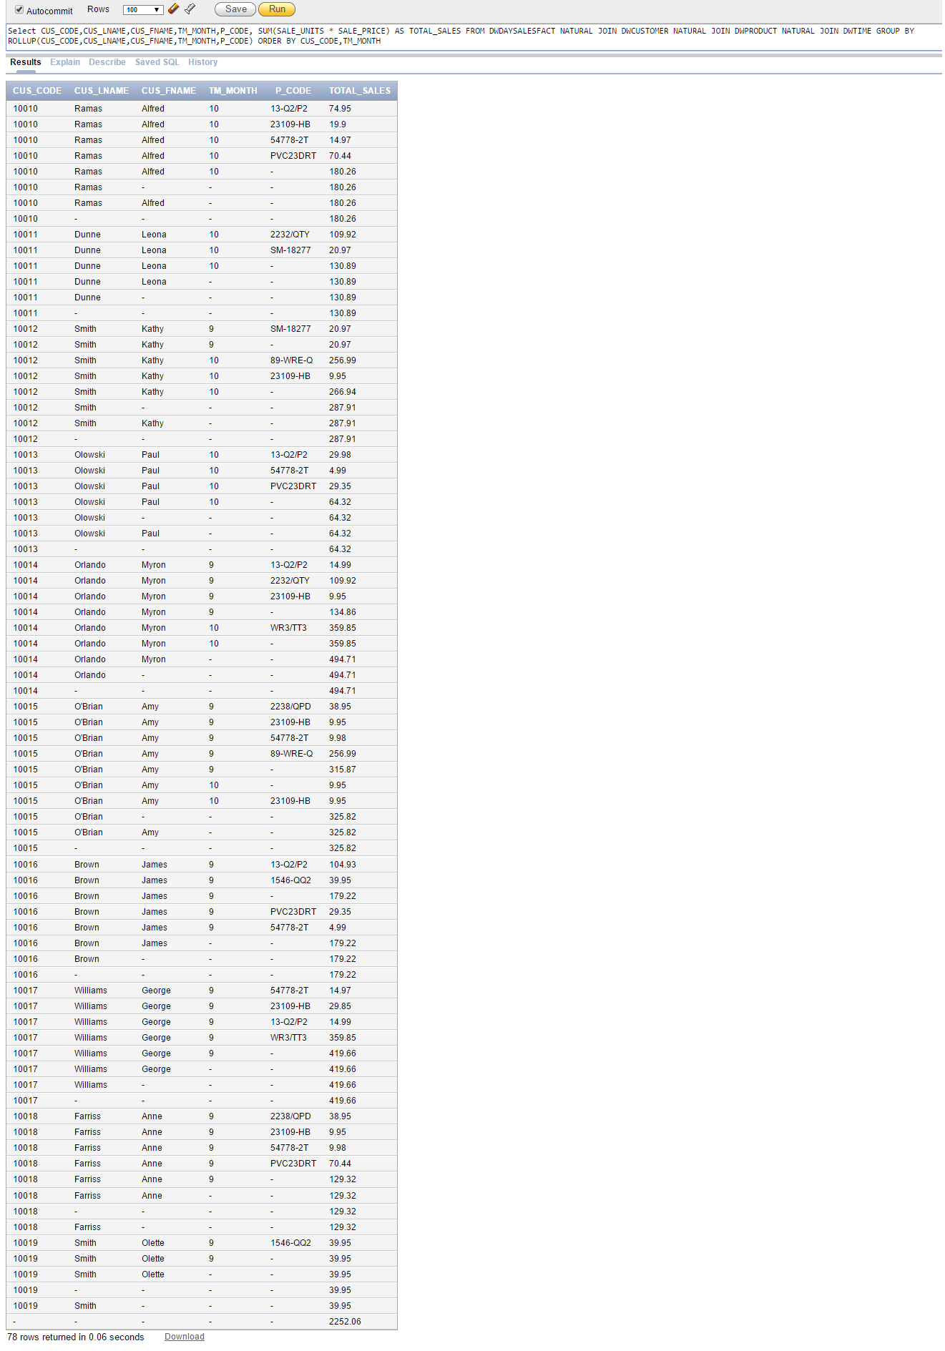

3. List the number of product sales (number of rows) and total sales by month, with subtotals by month and a grand total for all sales.

Solution:
Select TM_MONTH, COUNT(SALE_UNITS) AS "NUMBER OF PRODUCT SALES", SUM(SALE_UNITS * SALE_PRICE) AS TOTAL_SALES FROM DWDAYSALESFACT NATURAL JOIN DWTIME GROUP BY ROLLUP(TM_MONTH) ORDER BY TM_MONTH

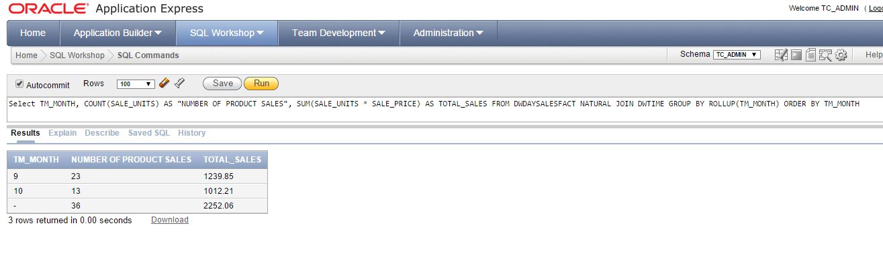

4. List the number of product sales (number of rows) and total sales by month and product category with subtotals by month and product category and a grand total for all sales.

Solution:
Select TM_MONTH,P_CATEGORY, COUNT(SALE_UNITS) AS "NUMBER OF PRODUCT SALES", SUM(SALE_UNITS * SALE_PRICE) AS TOTAL_SALES FROM DWDAYSALESFACT NATURAL JOIN DWPRODUCT NATURAL JOIN DWTIME GROUP BY ROLLUP(TM_MONTH,P_CATEGORY) ORDER BY TM_MONTH,P_CATEGORY

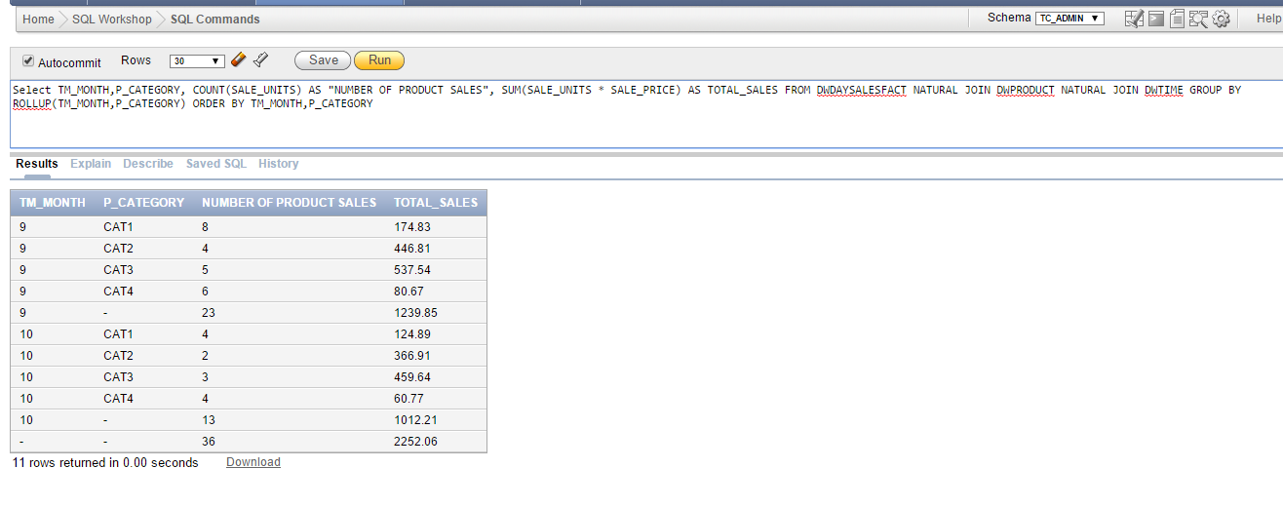

- Using the answer to problem 4 as your base, what command would you need to generate the same output but with subtotals in all columns?

Solution:
Select TM_MONTH,P_CATEGORY, COUNT(SALE_UNITS) AS "NUMBER OF PRODUCT SALES", SUM(SALE_UNITS * SALE_PRICE) AS TOTAL_SALES FROM DWDAYSALESFACT NATURAL JOIN DWPRODUCT NATURAL JOIN DWTIME GROUP BY CUBE(TM_MONTH,P_CATEGORY) ORDER BY TM_MONTH,P_CATEGORY

